**CHAROTAR UNIVERSITY OF SCIENCE AND TECHNOLOGY**

**DEVANG PATEL INSTITUTE OF ADVANCE TECHNOLOGY AND RESEARCH**

**DEPARTMENT OF COMPUTER ENGINEERING**

**Subject Name**: Advanced Java Programming **Semester**: 5th Sem

**Subject Code**: CE376

**Academic year:** 2020-21

Practical List

|  |  |  |
| --- | --- | --- |
| **Sr. No** | **Practical Aim** | Page No. |
| 1 | Create following table using mysql and perform following task. | 3 |
|  | a. Fetch and display records from a table using field index |
|  | b. Fetch and display records from a table using Result set metadata. |
|  | c. Display database properties using Database metadata |
|  | d. Using prepared statement perform insert, update and delete operations. |
|  | e. Perform insert, update and delete using callable statement. |
|  | f. Perform commit and set auto commit. |
|  | g. Display Scrollable Record Set |
| 2. | Write a Servlet which prints a greeting message on Browser. | 20 |
| 3. | Write a Servlet which takes two numbers from client using HTML form and display addition of both the numbers. | 24 |
| 4. | Write a Servlet to demonstrate the use of ServletConfig and ServletContext objects. | 26 |
| 5. | Write a Servlet to demonstrate the difference between RequestDispatcher’s forward method and sendRedirect method. | 30 |
| 6. | Create Login and Logout modules using Servlet and HttpSession. | 37 |
| 7. | Create a Filter which allows only specific set of IP addresses to access application. Allowed IP addresses to be configured in Context Parameter. | 42 |
| 8. | Create a JSP page that display number of hits to the page. | 44 |
| 9. | Develop JSP page to demonstrate various JSP directives and actions. | 45 |
| 10. | Create a JSP page which accepts a number from user and display table of that number using core tag library. | 47 |
| 11. | Develop a JSP page that display Student information from database using SQL Tag Library. | 49 |

**PRACTICAL-1**

**AIM:** [**Create following table using mysql and perform following task.]**

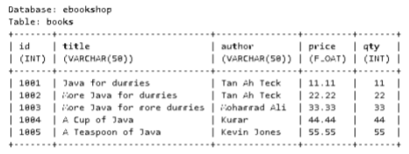

**a. Fetch and display records from a table using field index**

**b. Fetch and display records from a table using Result set metadata.**

**c. Display database properties using Database metadata**

**d. Using prepared statement perform insert, update and delete operations.**

**e. Perform insert, update and delete using callable statement.**

**f. Perform commit and set auto commit.**

**g. Display Scrollable Record Set**

**PROGRAM:**

import java.sql.*;

import java.util.*;

public class first {

public static void main(String[] args) throws Exception {

int menu = 0;

Scanner sr = new Scanner(System.in);

try{

Class.forName("com.mysql.jdbc.Driver");

//MAKING CONNECTION TO DB

Connection con = DriverManager.getConnection("jdbc:mysql://localhost:3306/ebookshop", "root", "");

do{

System.out.println("\nWHAT DO YOU WANT TO PERFORM?");

System.out.println("1. Display Records");

System.out.println("2. ResultSet Metadat");

System.out.println("3. Database Metadata");

System.out.println("4. Insert Record");

System.out.println("5. Update Records");

System.out.println("6. Delete Records");

System.out.println("7. Callable Insert");

System.out.println("8. Callable Update");

System.out.println("9. Callable Delete");

System.out.println("10. Commit And Auto-Commit");

System.out.println("11. Scrollabe Record Set");

System.out.println("0. Exit");

menu = sr.nextInt();

switch(menu){

case 1:

//DISPLAYING RECORDS

Statement stmt = con.createStatement();

ResultSet rs = stmt.executeQuery("select * from books");

System.out.println("\nmsg: Displaying Table:");

while(rs.next()){

System.out.println(rs.getInt(1) + " | " + rs.getString(2) + " | " + rs.getString(3) + " | " + rs.getFloat(4) + " | " + rs.getInt(5));

}

break;

case 2:

Statement stmtm = con.createStatement();

//Retrieving the data

ResultSet rsm = stmtm.executeQuery("select * from books");

ResultSetMetaData rsMetaData = rsm.getMetaData();

//Number of columns

System.out.println("Number of columns: "+rsMetaData.getColumnCount());

//Column name

System.out.println("1st Column Name: "+rsMetaData.getColumnName(1));

//Name of Table

System.out.println("Table Name: "+rsMetaData.getTableName(1));

//Columns of Table

System.out.println("Total columns: "+rsMetaData.getColumnCount());

//Type of 1st column

System.out.println("1st Column Type: "+rsMetaData.getColumnTypeName(1));

break;

case 3:

//DATABASE METADATA

DatabaseMetaData databaseMetaData = con.getMetaData();

//Print TABLE_TYPE "TABLE"

ResultSet resultSet = databaseMetaData.getTables(null, null, null, new String[]{"TABLE"});

System.out.println("\nPrinting TABLE_NAME:");

while(resultSet.next()){

System.out.println(resultSet.getString("TABLE_NAME"));

}

System.out.println("\nDatabase Info: ");

System.out.println("Driver Name: "+databaseMetaData.getDriverName());

System.out.println("Driver Version: "+databaseMetaData.getDriverVersion());

System.out.println("UserName: "+databaseMetaData.getUserName());

System.out.println("Database Product Name: "+databaseMetaData.getDatabaseProductName());

System.out.println("Database Product Version: "+databaseMetaData.getDatabaseProductVersion());

ResultSet columns = databaseMetaData.getColumns(null,null, "books", null);

System.out.println("\nPrinting COLUMN_INFO:");

while(columns.next())

{

String columnName = columns.getString("COLUMN_NAME");

String datatype = columns.getString("DATA_TYPE");

String columnsize = columns.getString("COLUMN_SIZE");

String decimaldigits = columns.getString("DECIMAL_DIGITS");

String isNullable = columns.getString("IS_NULLABLE");

String is_autoIncrment = columns.getString("IS_AUTOINCREMENT");

//Printing results

System.out.println("Column Name:" +columnName + "--- Datatype:" + datatype + "--- Column Size" + columnsize + "--- Decimal Digits:" + decimaldigits + "--- isNullable:" + isNullable + "--- Is autoIncrment:" + is_autoIncrment);

}

break;

case 4:

//INSERTING RECORDS

int id, qty;

float price;

String title, author;

System.out.println("\nInput Data for New Record:");

System.out.println("id (int)");

id = sr.nextInt();

sr.nextLine();

System.out.println("title (varchar)");

title = sr.nextLine();

System.out.println("author (varchar)");

author = sr.nextLine();

System.out.println("price (float)");

price = sr.nextFloat();

System.out.println("qty (int)");

qty = sr.nextInt();

PreparedStatement pstmt = con.prepareStatement("insert into books values(?,?,?,?,?)");

pstmt.setInt(1, id);

pstmt.setString(2, title);

pstmt.setString(3, author);

pstmt.setFloat(4, price);

pstmt.setInt(5, qty);

int i = pstmt.executeUpdate();

System.out.println("\nmsg: " + i + " records inserted\n");

break;

case 5:

//UPDATING RECORDS

System.out.println("\nInput Data to Update Records:");

System.out.println("ID of record you want to Update");

int id2 = sr.nextInt();

sr.nextLine();

System.out.println("Update Book title to ");

String title2 = sr.nextLine();

PreparedStatement ustmt = con.prepareStatement("UPDATE books SET title = ? WHERE id = ?");

ustmt.setString(1, title2);

ustmt.setInt(2, id2);

int rowAffected = ustmt.executeUpdate();

System.out.println("\nmsg: "+rowAffected + " records updated.\n");

break;

case 6:

//DELETING RECORDS

System.out.println("\nInput Data to Delete Records:");

System.out.println("ID of record you want to Delete");

int id3 = sr.nextInt();

PreparedStatement dstmt = con.prepareStatement("delete from books where id=?");

dstmt.setInt(1, id3);

int rowDeleted = dstmt.executeUpdate();

System.out.println("\nmsg: "+rowDeleted + " records deleted.\n");

break;

case 7:

//CALLABLE INSERTING RECORDS

CallableStatement stmti= con.prepareCall("{call InsertData(?,?,?,?,?)}");

stmti.setInt(1, 1006);

stmti.setString(2, "Advance Java");

stmti.setString(3, "Shreyas Shah");

stmti.setFloat(4, 77);

stmti.setInt(5, 77);

stmti.execute();

System.out.println("Successeful Inserted");

break;

case 8:

//CALLABLE UPDATING RECORDS

CallableStatement stmtu= con.prepareCall("{call UpdateData(?,?)}");

stmtu.setInt(1, 1007);

stmtu.setString(2, "Advance Java Programming");

stmtu.execute();

System.out.println("Successfully Updated");

break;

case 9:

//CALLABLE DELETING RECORDS

CallableStatement stmtd= con.prepareCall("{call DeleteData(?)}");

stmtd.setInt(1, 1006);

stmtd.execute();

System.out.println("Successfully Deleted");

break;

case 10:

//COMMIT AND AUTO-COMMIT

con.setAutoCommit(false);

System.out.println("Type 1 to commit the querry");

short flag=sr.nextShort();

if (flag==1){

PreparedStatement comstnt = con.prepareStatement("insert into books values(?,?,?,?,?)");

comstnt.setInt(1, 1006);

comstnt.setString(2, "Advance Java");

comstnt.setString(3, "Shreyas Shah");

comstnt.setFloat(4, 77);

comstnt.setInt(5, 77);

comstnt.executeUpdate();

System.out.println("Quesry Executed.");

con.commit();

System.out.println("Quesry Commited.");

}

else{

System.out.println("Quesry Rollbacked.");

con.rollback();

}

break;

case 11:

//SCROLLABLE RECORD TYPE

Statement str=con.createStatement(ResultSet.TYPE_SCROLL_INSENSITIVE,ResultSet.CONCUR_READ_ONLY);

ResultSet rsr = str.executeQuery("select * from books");

rsr.first();

System.out.println("First Record...");

System.out.println(rsr.getInt(1) + "->"+ rsr.getString(2));

rsr.absolute(3);

System.out.println("Third Record...");

System.out.println(rsr.getInt(1) + "->"+ rsr.getString(2));

rsr.last();

System.out.println("Last Record...");

System.out.println(rsr.getInt(1) + "->"+ rsr.getString(2));

rsr.previous();

//rsr.relative(-1);

System.out.println("Last to First Record...");

System.out.println(rsr.getInt(1) + "->"+ rsr.getString(2));

break;

case 0:

System.out.println("\nExiting...\n");

break;

default:

System.out.println("\nWrong Input!\n");

break;

}

} while(menu != 0);

//CLOSING CONNECTION TO DB

con.close();

} catch(Exception e){

System.out.println("\nError: " + e);

}

}

}

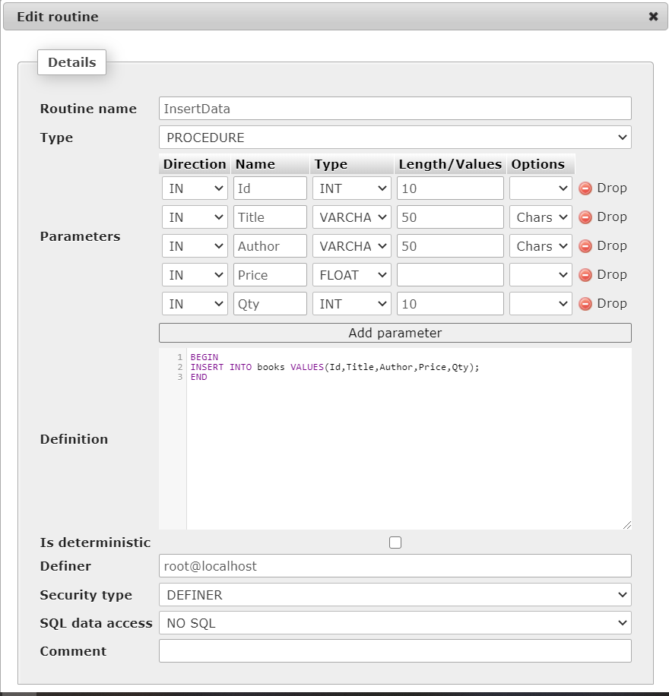

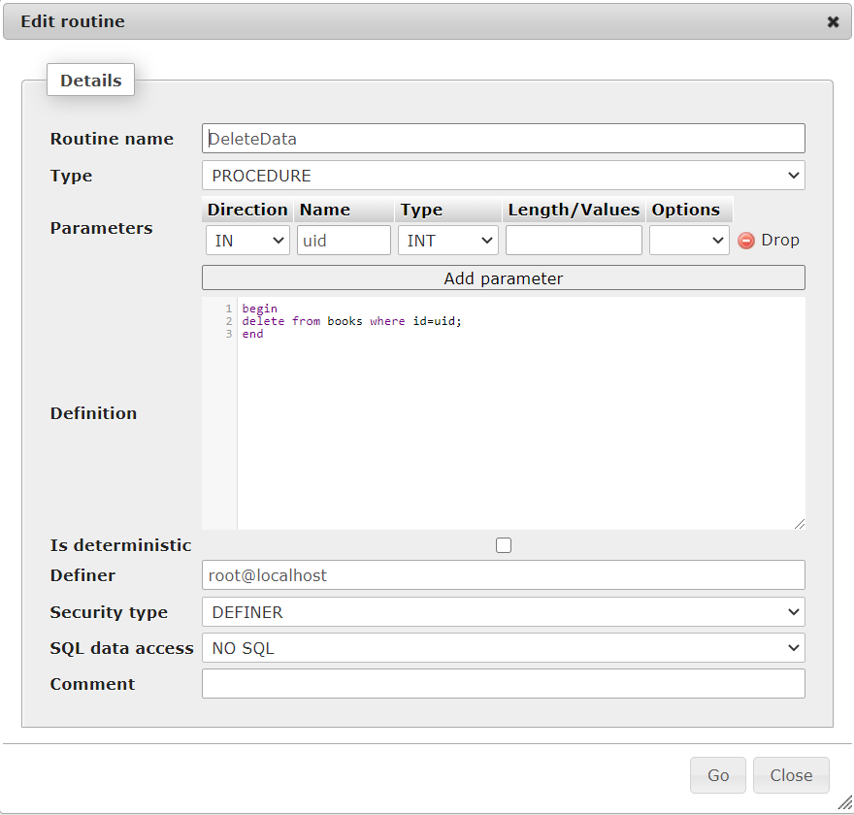

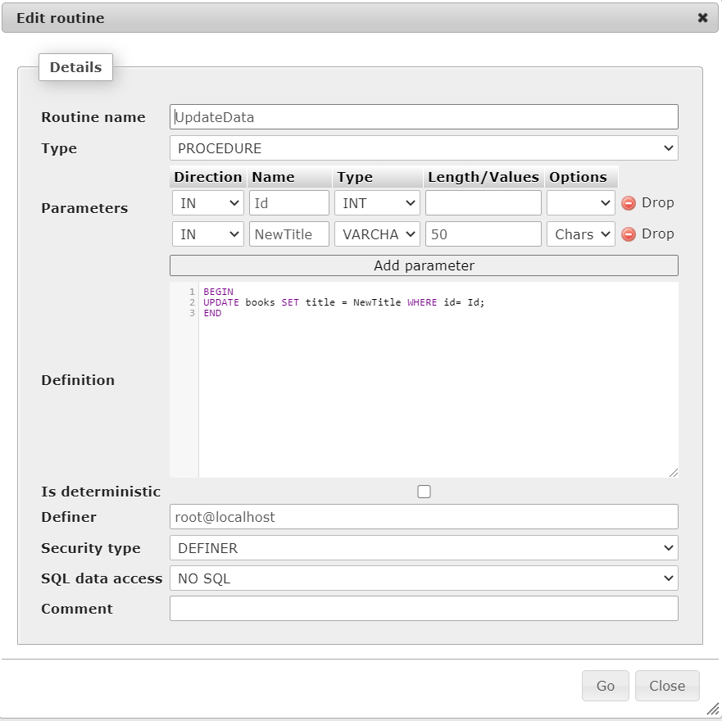

**OUTPUT:**

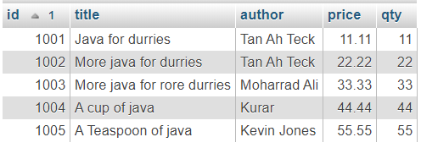

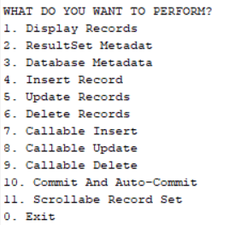

a. Fetch and display records from a table using field index:

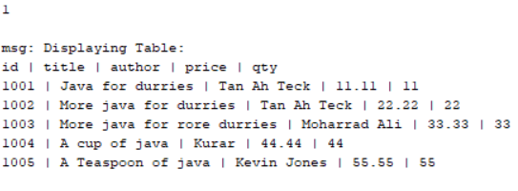

b. Fetch and display records from a table using Result set metadata:

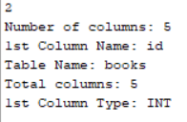

c. Display database properties using Database metadata:

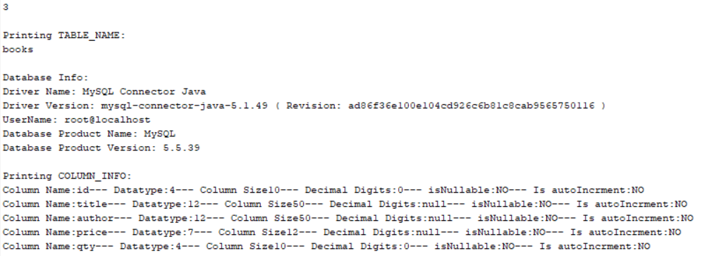

d. Using prepared statement perform insert, update and delete operations:

1)Insert:

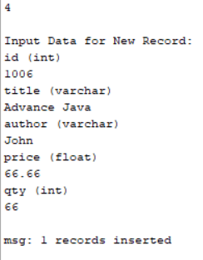

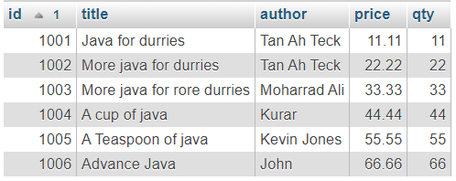

2)Update:

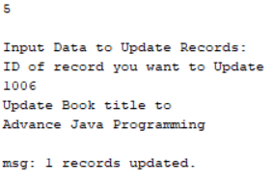

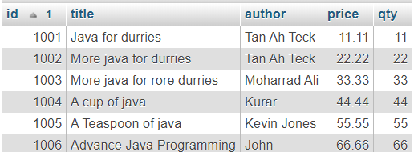

3)Delete:

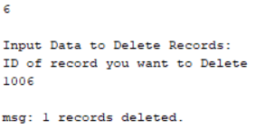



e. Perform insert, update and delete using callable statement:

1)Insert:



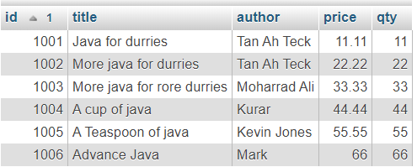

2)Update:



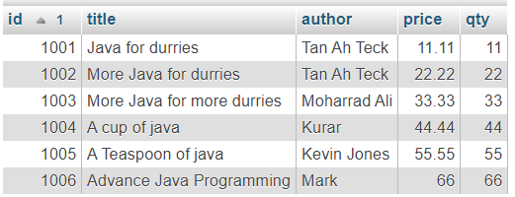

3)Delete:





f. Perform commit and set auto commit:

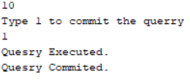

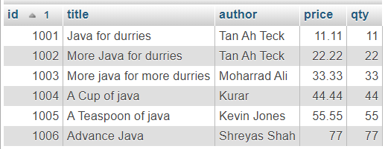

g. Display Scrollable Record Set:

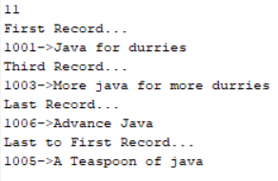

**CONCLUSION:**

We studied about JDBC and how to connect MySQL with in and perform basic tasks on records of the table.

**PRACTICAL-2**

**AIM: [Write a Servlet which prints a greeting message on Browser]**

**PROGRAM:**

/*

* To change this license header, choose License Headers in Project Properties.

* To change this template file, choose Tools | Templates

* and open the template in the editor.

*/

import java.io.IOException;

import java.io.PrintWriter;

import javax.servlet.ServletException;

import javax.servlet.http.HttpServlet;

import javax.servlet.http.HttpServletRequest;

import javax.servlet.http.HttpServletResponse;

/**

*

* @author kashy

*/

public class NewServlet extends HttpServlet {

/**

* Processes requests for both HTTP <code>GET</code> and <code>POST</code>

* methods.

*

* @param request servlet request

* @param response servlet response

* @throws ServletException if a servlet-specific error occurs

* @throws IOException if an I/O error occurs

*/

protected void processRequest(HttpServletRequest request, HttpServletResponse response)

throws ServletException, IOException {

response.setContentType("text/html;charset=UTF-8");

try (PrintWriter out = response.getWriter()) {

/* TODO output your page here. You may use following sample code. */

out.println("<!DOCTYPE html>");

out.println("<html>");

out.println("<head>");

out.println("<title>Servlet NewServlet</title>");

out.println("</head>");

out.println("<body>");

out.println("<h1>Welcome to Servlet!"+"</h1>");

out.println("</body>");

out.println("</html>");

}

}

// <editor-fold defaultstate="collapsed" desc="HttpServlet methods. Click on the + sign on the left to edit the code.">

/**

* Handles the HTTP <code>GET</code> method.

*

* @param request servlet request

* @param response servlet response

* @throws ServletException if a servlet-specific error occurs

* @throws IOException if an I/O error occurs

*/

@Override

protected void doGet(HttpServletRequest request, HttpServletResponse response)

throws ServletException, IOException {

processRequest(request, response);

}

/**

* Handles the HTTP <code>POST</code> method.

*

* @param request servlet request

* @param response servlet response

* @throws ServletException if a servlet-specific error occurs

* @throws IOException if an I/O error occurs

*/

@Override

protected void doPost(HttpServletRequest request, HttpServletResponse response)

throws ServletException, IOException {

processRequest(request, response);

}

/**

* Returns a short description of the servlet.

*

* @return a String containing servlet description

*/

@Override

public String getServletInfo() {

return "Short description";

}// </editor-fold>

}

**OUTPUT:**

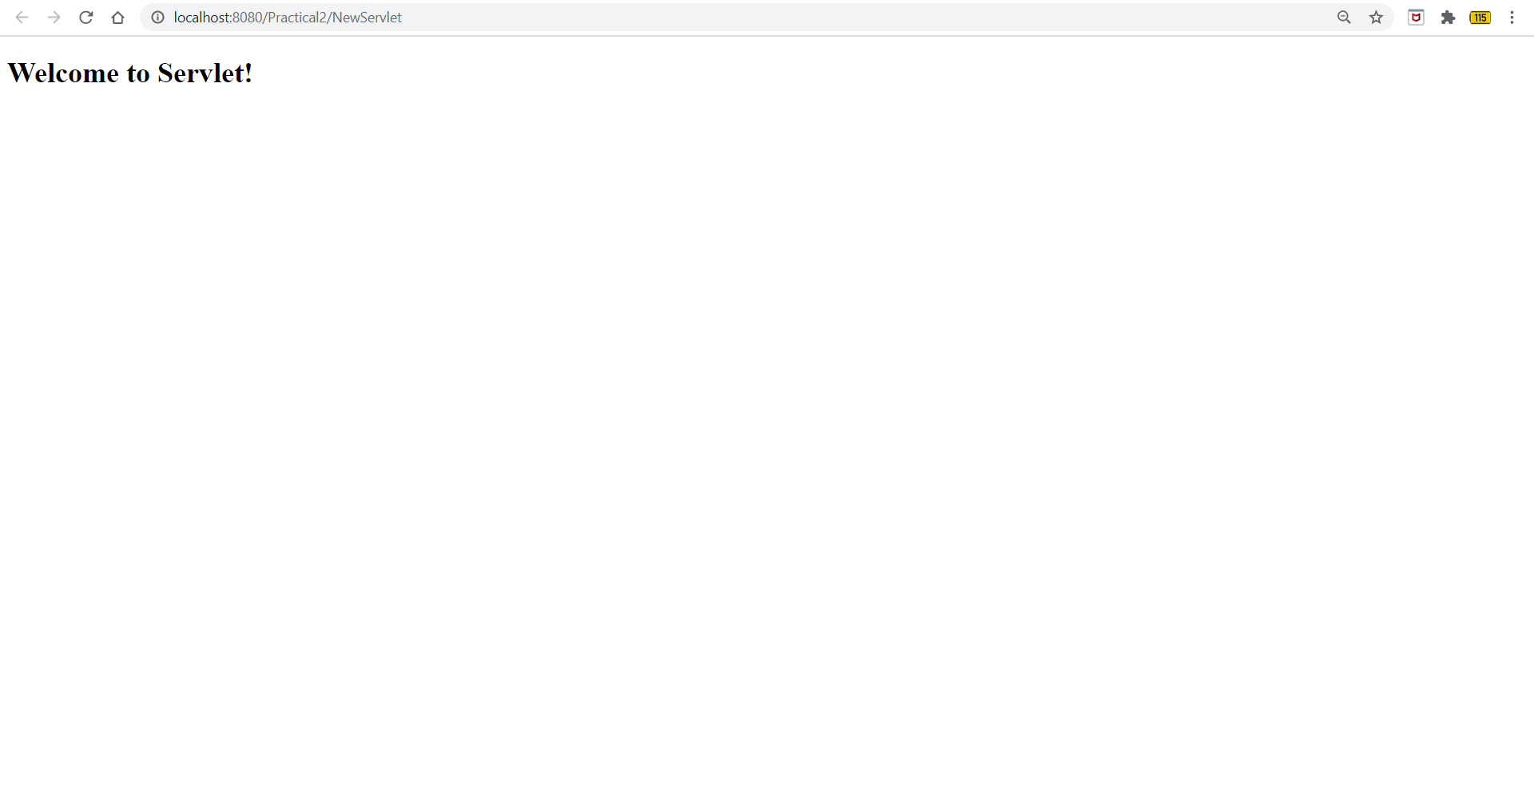

**CONCLUSION:**

In this practical we learnt how to develop a simple WebApplication project & write a Servlet which prints a greeting message on Browser.

**PRACTICAL-3**

**AIM: [Write a Servlet which takes two numbers from client from HTML form and display addition of both the numbers]**

**PROGRAM:**

***Index.html***

<!DOCTYPE html>

<html>

<head>

<title>Addition</title>

<meta charset="UTF-8">

<meta name="viewport" content="width=device-width, initial-scale=1.0">

</head>

<body>

<h1>Addition</h1>

<form action="Addition">

Number 1: <input type="text" name="no1"> <br><br>

Number 2: <input type="text" name="no2"> <br><br>

<input type="submit" value="Add">

</form>

</body>

***Addition.java***

@Override

protected void doGet(HttpServletRequest request, HttpServletResponse response)

throws ServletException, IOException {

//processRequest(request, response);

PrintWriter out = response.getWriter();

int no1 = Integer.parseInt(request.getParameter("no1"));

int no2 = Integer.parseInt(request.getParameter("no2"));

out.println("<h1>Result : "+(no1+no2)+"</h1>");

}

**OUTPUT:**

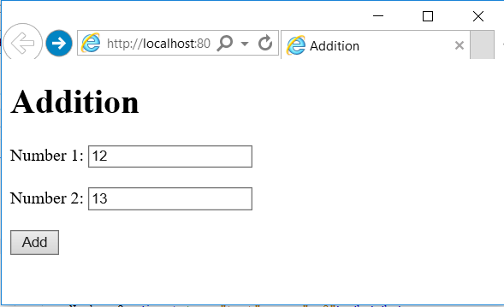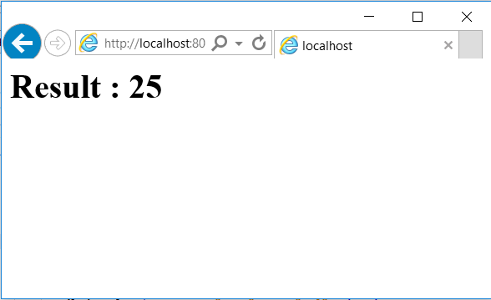

**CONCLUSION:**

In this practical we learnt how to develop a html file in servlet & perform addition of two numbers on Browser.

**PRACTICAL-4**

**AIM: [Write a Servlet to demonstrate the difference between Request Dispatcher’s forward method and sendRedirect method]**

**PROGRAM:**

***1.Servlet***

import java.io.IOException; import java.io.PrintWriter;

import javax.servlet.ServletConfig; import javax.servlet.ServletContext; import javax.servlet.ServletException;

import javax.servlet.annotation.WebServlet; import javax.servlet.http.HttpServlet;

import javax.servlet.http.HttpServletRequest; import javax.servlet.http.HttpServletResponse;

@WebServlet("/MyServ")

public class MyServ extends HttpServlet {

private static final long serialVersionUID = 1L; public MyServ() {

super();

// TODO Auto-generated constructor stub

}

protected void doGet(HttpServletRequest request, HttpServletResponse response)

throws ServletException, IOException {

response.setContentType("text/html"); PrintWriter out = response.getWriter(); out.print("<h3>Servlet Config object</h3>");

ServletConfig config=getServletConfig(); String name=config.getInitParameter("name"); out.print("Name: "+name);

String id=config.getInitParameter("id"); out.print("ID: "+id);

out.print("<h3>Servlet Config object</h3>"); ServletContext context=getServletContext(); String prac=context.getInitParameter("practical"); out.println("practical aim is="+prac);

}

}

***2.Web.xml***

<?xml version="1.0" encoding="UTF-8"?>

<web-app xmlns:xsi="<http://www.w3.org/2001/XMLSchema-instance>" xmlns="<http://xmlns.jcp.org/xml/ns/javaee>" xsi:schemaLocation="<http://xmlns.jcp.org/xml/ns/javaee> [http://xmlns.jcp.org/xml/ns/javaee/web-app_3_1.xsd"](http://xmlns.jcp.org/xml/ns/javaee/web-app_3_1.xsd) id="WebApp_ID" version="3.1">

<display-name>Config_Context</display-name>

<welcome-file-list>

<welcome-file>index.html</welcome-file>

<welcome-file>index.htm</welcome-file>

<welcome-file>index.jsp</welcome-file>

<welcome-file>default.html</welcome-file>

<welcome-file>default.htm</welcome-file>

<welcome-file>default.jsp</welcome-file>

</welcome-file-list>

<servlet>

<servlet-name>MyServ</servlet-name>

<servlet-class>MyServ</servlet-class>

<init-param>

<param-name>name</param-name>

<param-value>Servlet</param-value>

</init-param>

<init-param>

<param-name>id</param-name>

<param-value>DEPSTAR-CSE</param-value>

</init-param>

</servlet>

<context-param>

<param-name>practical</param-name>

<param-value>AJP Practical</param-value>

</context-param>

<servlet-mapping>

<servlet-name>MyServ</servlet-name>

<url-pattern>/MyServ</url-pattern>

</servlet-mapping>

</web-app>

# OUTPUT:

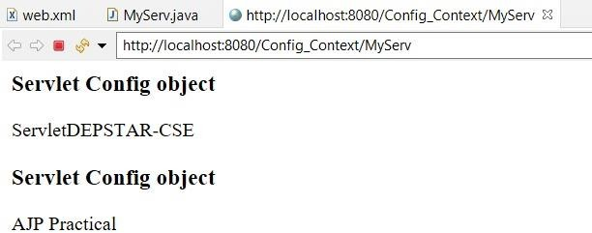

**CONCLUSION:**

In this practical we learnt about ServletConfig and ServletContext objects and how to use them.

**PRACTICAL-5**

**AIM: [Write a Servlet to demonstrate the difference between Request Dispatcher’s forward method and sendRedirect method]**

**PROGRAM:**

***Index.html***

# <!DOCTYPE html>

# <html>

# <head>

# <title>Login</title>

# <meta charset="UTF-8">

# <meta name="viewport" content="width=device-width, initial-scale=1.0">

# 

# </head>

# <body>

# <h1>Log In</h1>

# <form action="Login">

# Username: <input type="text" name="user"> <br><br>

# Password: <input type="text" name="pass"> <br><br>

# <input type="submit" value="Login">

# </form>

# </body>

# </html>

***NewServlet.java***

/*

* To change this license header, choose License Headers in Project Properties.

* To change this template file, choose Tools | Templates

* and open the template in the editor.

*/

import java.io.IOException;

import java.io.PrintWriter;

import static java.lang.System.out;

import javax.servlet.RequestDispatcher;

import javax.servlet.ServletException;

import javax.servlet.http.HttpServlet;

import javax.servlet.http.HttpServletRequest;

import javax.servlet.http.HttpServletResponse;

/**

*

* @author smart

*/

public class NewServlet extends HttpServlet {

/**

* Processes requests for both HTTP <code>GET</code> and <code>POST</code>

* methods.

*

* @param request servlet request

* @param response servlet response

* @throws ServletException if a servlet-specific error occurs

* @throws IOException if an I/O error occurs

*/

protected void processRequest(HttpServletRequest request, HttpServletResponse response)

throws ServletException, IOException {

response.setContentType("text/html;charset=UTF-8");

try (PrintWriter out = response.getWriter()) {

/* TODO output your page here. You may use following sample code. */

// out.println("<!DOCTYPE html>");

// out.println("<html>");

// out.println("<head>");

// out.println("<title>Servlet NewServlet</title>");

// out.println("</head>");

// out.println("<body>");

// out.println("<h1>Servlet NewServlet at " + request.getContextPath() + "</h1>");

// out.println("</body>");

// out.println("</html>");

}

}

// <editor-fold defaultstate="collapsed" desc="HttpServlet methods. Click on the + sign on the left to edit the code.">

/**

* Handles the HTTP <code>GET</code> method.

*

* @param request servlet request

* @param response servlet response

* @throws ServletException if a servlet-specific error occurs

* @throws IOException if an I/O error occurs

*/

@Override

protected void doGet(HttpServletRequest request, HttpServletResponse response)

throws ServletException, IOException {

//processRequest(request, response);

String user = request.getParameter("user");

String pass = request.getParameter("pass");

//out.println("hello "+user);

if(user.equals("kashyap") && pass.equals("123")){

//response.sendRedirect("Dashboard.jsp");

RequestDispatcher rd = request.getRequestDispatcher("Dashboard.jsp");

rd.forward(request, response);

}

else

{

out.println("Incorrect Details!");

}

}

/**

* Handles the HTTP <code>POST</code> method.

*

* @param request servlet request

* @param response servlet response

* @throws ServletException if a servlet-specific error occurs

* @throws IOException if an I/O error occurs

*/

@Override

protected void doPost(HttpServletRequest request, HttpServletResponse response)

throws ServletException, IOException {

processRequest(request, response);

}

/**

* Returns a short description of the servlet.

*

* @return a String containing servlet description

*/

@Override

public String getServletInfo() {

return "Short description";

}// </editor-fold>

}

***Dashboard.jsp***

<html>

<head>

<meta http-equiv="Content-Type" content="text/html; charset=UTF-8">

<title>JSP Page</title>

</head>

<body>

<h1>Welcome <%=request.getParameter("user")%></h1>

</body>

</html>

**OUTPUT:**

# *With RequestDispatcher’s Forward:*

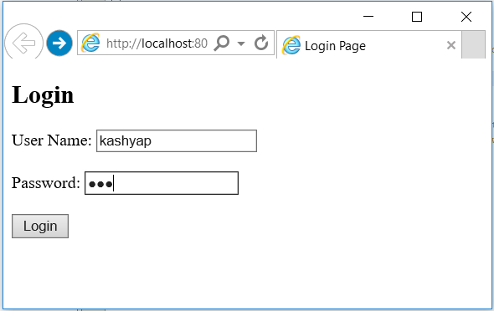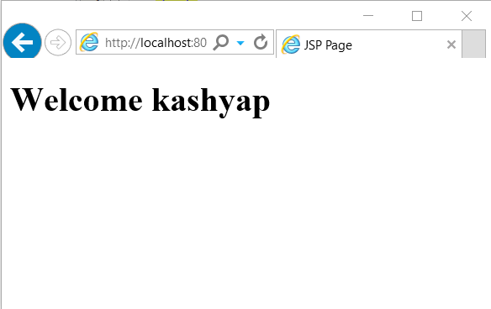

# The object isn’t lost as it was forwarded further to Dashboard.jsp with RequestDispatcher’s Forward method.

# *With sendRedirect() method:*

# C:\Users\smart\Desktop\College\College\SEM 5\IT371 Advance JAVA Programming\Prac5\1.PNGC:\Users\smart\Desktop\College\College\SEM 5\IT371 Advance JAVA Programming\Prac5\3.PNG

# The object request and response is lost, so the output in null

**CONCLUSION:**

We studied the difference between RequestDispatcher’s forward method and sendRedirect method with a simple example of login.

**PRACTICAL 6**

**AIM: [Create Login and Logout modules using Servlet and HttpSession.]**

# PROGRAM:

# *Index.html*

# <!DOCTYPE html>

# <html>

# <head>

# <title>Login</title>

# <meta charset="UTF-8">

# <meta name="viewport" content="width=device-width, initial-scale=1.0">

# 

# </head>

# <body>

# <h1>Log In</h1>

# <form action="Login">

# Username: <input type="text" name="user"> <br><br>

# Password: <input type="text" name="pass"> <br><br>

# <input type="submit" value="Login">

# </form>

# </body>

# </html>

# *Login.java (Servlet)*

# package com.demo.controller;

# import java.io.IOException;

# import java.io.PrintWriter;

# import javax.servlet.ServletException;

# import javax.servlet.http.HttpServlet;

# import javax.servlet.http.HttpServletRequest;

# import javax.servlet.http.HttpServletResponse;

# public class Login extends HttpServlet {

# protected void processRequest(HttpServletRequest request, HttpServletResponse response)

# throws ServletException, IOException {

# response.setContentType("text/html;charset=UTF-8");

# try (PrintWriter out = response.getWriter()) {

# /* TODO output your page here. You may use following sample code. */

# out.println("<!DOCTYPE html>");

# out.println("<html>");

# out.println("<head>");

# out.println("<title>Servlet Login</title>");

# out.println("</head>");

# out.println("<body>");

# out.println("</body>");

# out.println("</html>");

# }

# }

# 

# @Override

# protected void doGet(HttpServletRequest request, HttpServletResponse response)

# throws ServletException, IOException {

# PrintWriter out = response.getWriter();

# String user = request.getParameter("user");

# String pass = request.getParameter("pass");

# if("Mark".equals(user)){

# if("mark".equals(pass)){

# out.println("<h1>LogIn Successful</h1>");

# out.println("<h3>Username: "+user+"</h3>");

# }

# else{

# out.println("<h1>LogIn unsuccessful</h1>");

# out.println("<h3>Message: Wrong Password.</h3>");

# }

# }

# else{

# out.println("<h1>LogIn unsuccessful</h1>");

# out.println("<h3>Message: User not found.</h3>");

# }

# }

# @Override

# public String getServletInfo() {

# return "Short description";

# }// </editor-fold>

# }

# OUTPUT:

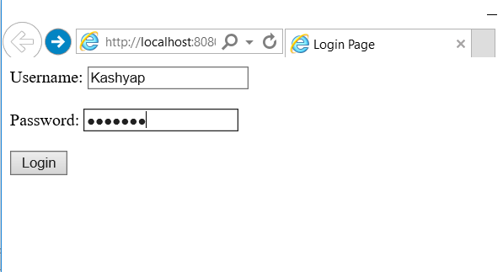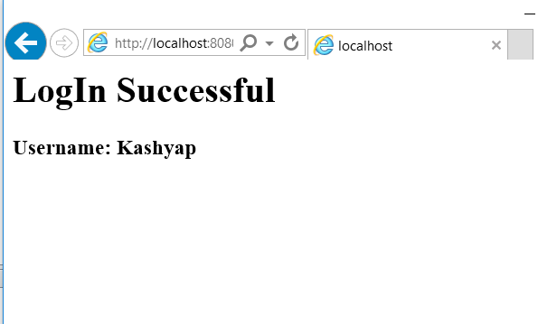

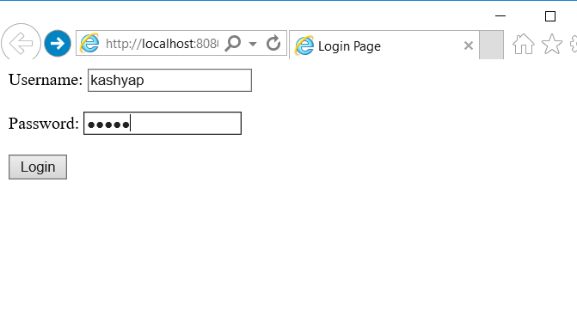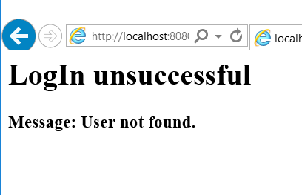

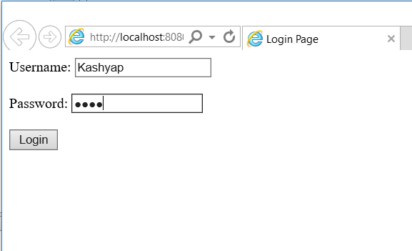 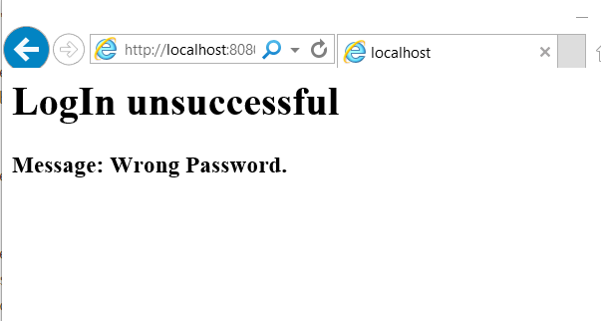

**CONCLUSION:**

We created basic Servlet project for Login process and displaying messages accordingly.

**PRACTICAL 7**

**AIM: [Create a filter which allows only specific set of IP addresses to access application. Allowed IP addresses to be configured in context parameter.]**

**PROGRAM:**

import java.io.IOException;  
import java.io.PrintWriter;  
import javax.servlet.Filter;  
import javax.servlet.FilterChain;  
import javax.servlet.FilterConfig;  
import javax.servlet.ServletException;  
import javax.servlet.ServletRequest;  
import javax.servlet.ServletResponse;  
import javax.servlet.annotation.WebFilter; import javax.servlet.http.HttpServletRequest; import javax.servlet.http.HttpServletResponse;

@WebFilter("/Servlet")  
public class IPFilter implements Filter {

private static String allowIP = "0:0:0:0:0:0:0:1";

public IPFilter() {

// TODO Auto-generated constructor stub

}

public void destroy() {  
// TODO Auto-generated method stub

}

public void doFilter(ServletRequest request, ServletResponse response, FilterChain chain) throws IOException, ServletException {

HttpServletRequest req = (HttpServletRequest) request;

HttpServletResponse res = (HttpServletResponse) response;

PrintWriter out = res.getWriter();  
String ipAddr = req.getRemoteAddr();

System.out.println("IP-Addr: " + ipAddr);

if (ipAddr.equals(allowIP)) {

chain.doFilter(request, response);

} else {

out.println("Request Denied!");

}

chain.doFilter(request, response);

}

/**  
* @see Filter#init(FilterConfig)

*/

public void init(FilterConfig fConfig) throws ServletException { /

/ TODO Auto-generated method stub

}

}

**CONCLUSION:**

In this practical, we learnt how Filters can be used in Servlet programming.

**PRACTICAL 8**

**AIM: [Create a JSP page that display number of hits to the page.]**

**PROGRAM:**

<%@ page import = "java.io.*,java.util.*" %>

<html>

<head>

<title>Application object in JSP</title>

</head>

<body>

<%

Integer hitsCount = (Integer)application.getAttribute("hitCounter"); if( hitsCount ==null || hitsCount == 0 ) {

/* First visit */  
out.println("Hit Counter Practical!");

hitsCount = 1;

} else {

/* return visit */  
out.println("Welcome back to my website!");

hitsCount += 1;

}

application.setAttribute("hitCounter", hitsCount);

%>

<center>

<p>Total number of visits: <%= hitsCount%></p>

</center>

</body>

</html>

**CONCLUSION:**

In this practical, we learnt about application implicit object in JSP.

**PRACTICAL 9**

**AIM: [Create a JSP page to demonstrate various JSP directives and actions.]**

**PROGRAM:**

**include.html**

!DOCTYPE html>  
<html>  
<head>  
<meta charset="ISO-8859-1"> <title>Insert title here</title>

</head>

<body>  
<h3>Content using include action</h3> </body>  
</html>

**page1.jsp**

<%@ page language="java" contentType="text/html; charset=ISO-8859-1" pageEncoding="ISO-8859-1"%>

<%@ taglib uri="http://java.sun.com/jsp/jstl/core" prefix="c" %> <!DOCTYPE html>  
<html>  
<head>

<meta charset="ISO-8859-1"> <title>Insert title here</title> </head>  
<body>

<h3>JSP include action tag</h3>  
<jsp:include page="include.html"></jsp:include> <form action="redirect.jsp">  
<input type=submit value="Click me to redirect!"> </form>  
</body>  
</html>

**redirect.jsp**

<%@ page language="java" contentType="text/html; charset=ISO-8859-1" pageEncoding="ISO-8859-1"%>

<%@ page import="java.util.Date"%>

<%@ taglib uri="http://java.sun.com/jsp/jstl/core" prefix="c" %> <!DOCTYPE html>  
<html>  
<head>

<meta charset="ISO-8859-1"> <title>Insert title here</title> </head>  
<body>

<h3>Date: </h3>  
<p>Date class imported using import attribute of page directive and core tags are imported using taglib directive to display date value</p>  
<c:set var="Date" value="<%=new java.util.Date()%>" />  
<c:out value="${Date}"></c:out>  
</body>  
</html>

# OUTPUT:

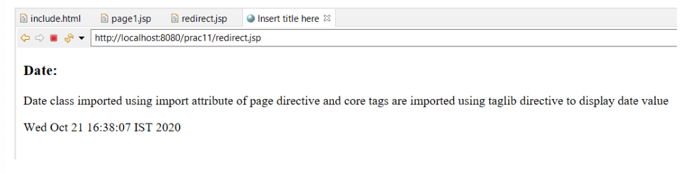

**CONCLUSION:**

In this practical, we learnt about various JSP directives and actions and used a few in this practical.

**PRACTICAL 10**

**AIM: [Create a JSP page which accepts a number from user and display the table of that nuber using core tag library.]**

**PROGRAM:**

**index.html**

<!DOCTYPE html>  
<html>  
<head>  
<meta charset="ISO-8859-1"> <title>Insert title here</title> </head>

<body>  
<form action="table.jsp">  
Enter a number  
<input type="text" name="num"> </form>  
</body>

</html>

**table.jsp**

<%@ page language="java" contentType="text/html; charset=ISO-8859-1" pageEncoding="ISO-8859-1"%>

<%@ taglib uri="http://java.sun.com/jsp/jstl/core" prefix="c" %> <!DOCTYPE html>  
<html>  
<head>

<meta charset="ISO-8859-1"> <title>Insert title here</title> </head>  
<body>

<c:set var="val" scope="session" value="${param.num}"/> <c:forEach var="i" begin="1" end="10">

<c:out value="${i*val}"/><p> </c:forEach>

</body>

</html>

# OUTPUT:

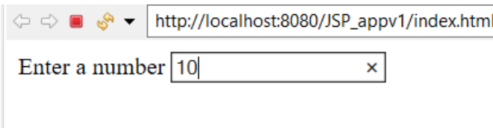

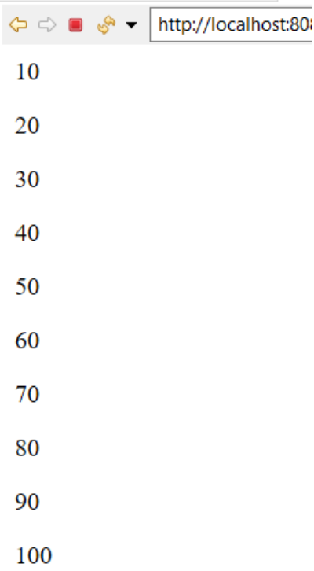

**CONCLUSION:**

In this practical, we learnt about core tags of JSTL.

**PRACTICAL 11**

**AIM: [Develop a JSP page that display Student information from database using SQL Tag Library.]**

**PROGRAM:**

<%@ page language="java" contentType="text/html; pageEncoding="ISO-8859-1"%>  
<%@ taglib uri="http://java.sun.com/jsp/jstl/sql" prefix="sql" %> <%@ taglib uri="http://java.sun.com/jsp/jstl/core" prefix="c" %>

<!DOCTYPE html>  
<html>  
<head>  
<meta charset="ISO-8859-1"> <title>Dsiplay using JSP</title> </head>

<body>

<sql:setDataSource var="db" driver="com.mysql.jdbc.Driver" url="jdbc:mysql://localhost/db_jsp"  
user="root" password=""/>

<sql:query dataSource="${db}" var="rs"> SELECT * from student;  
</sql:query>

<table border="2" width="100%"> <tr>  
<th>ID</th>  
<th>Name</th>

</tr>

<c:forEach var="t" items="${rs.rows}"> <tr>  
<td><c:out value="${t.sid}"/></td>

<td><c:out value="${t.sname}"/></td>

<td><c:out value="${t.branch}"/></td>

<td><c:out value="${t.semester}"/></td>

</tr> </c:forEach>

</table>

</body>

</html>

# OUTPUT:

**1. Data from DB**

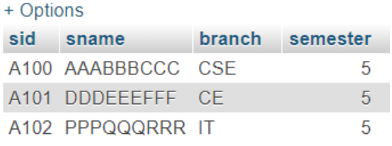

**2. Displayed using JSP**

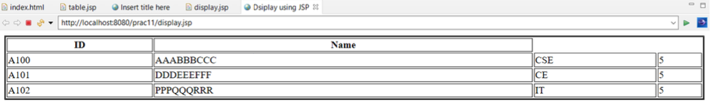

**CONCLUSION:**

In this practical, we learnt about sql tags of JSTL.